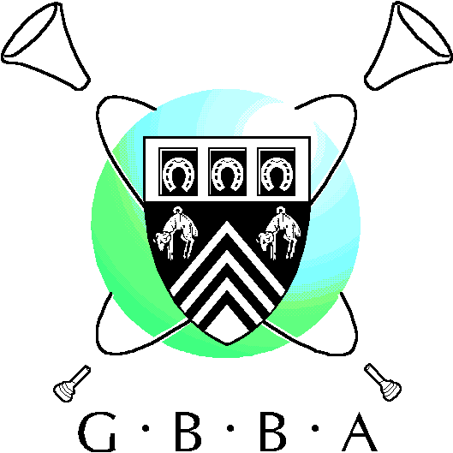**GBBA Own Choice Contest**

**March & Test Piece**

Sunday 24thNovember 2024

**Adjudicator:**

Dr Brett Baker DMA, MA, ARCM (Hons)

**Venue:**

Chosen Hill School, Brookfield Road, Churchdown, Glos, GL3 2PL

(3 words: ///fruit.milk.code)

**Competition Requirements:**

**Class A:** Championship, First, Second, Third & Fourth Section Bands.

An Own Choice March and Test Piece

**Class B -** Youth, Training & Unregistered Bands

To encourage class B participation, bands may perform **either** of the following:

1. A March and Test piece.
2. A fifteen-minute programme that includes a March.

**Entry Fee:**

* **Class A:** £125 for GBBA members / £140 non GBBA members
* **Class B:** £40

**Entry Form. Use the following link:**

<https://docs.google.com/forms/d/e/1FAIpQLSfjghjxJaLmWkNJpR7yXjmc1I6gZvNEagI446bc95vr-rl8qQ/viewform?usp=pp_url>

**Closing Date:**

Friday 20th September 2024

**BACs Payments to**:

Gloucestershire Brass Band Association

Sort Code 40-22-09 A/c No 80388629

**Contest Secretary:**

Ian Ford

[**ianbford63@gmail.com**](mailto:ianbford63@gmail.com)